**Capstone Project Week 1&2**

**LONDON HOUSING MARKET AFTER BREXIT**

**BACKGROUND**

Since mid-2016 to January 31st 2020, the British government was dealing with Brexit and the British withdrawal from the European Union had affected the housing market for both citizens and overseas buyers as the government made it more expensive for landlords and overseas buyers to purchase houses (<https://www.bullionvault.com/gold-news/uk-house-prices-022420201)>. Especially, real estate in London comes at quite a steep price. It is this exact reason why you should not settle and find only the best fit for your needs (<https://data.london.gov.uk/housing/housing-market-report/)>. Therefore, I am going to use the latest data for buyers to make wise and effective decisions.

**BUSINESS PROBLEM AND SOLUTION**

What is the wisest investment option for people who seek a house in London now that Brexit is finalised?

In order to recommend venues and the current average price of real estate, the neighbourhoods of London will be clustered. Recommendations of profitable venues according to amenities and essential facilities such as schools, hospitals & supermarkets will be provided.

**DATA**

Data on London properties and the relative price paid data were extracted from the HM Land Registry (<http://landregistry.data.gov.uk/)>. If the building is divided into flats, there will be a SAON; Street; Locality; Town/City; District; County. For data visualisation, FourSquare API interface will be used. Then the collected data from HM Land Registry and Foursquare API will be merged and show the most profitable investments in London.

**METHODOLOGY**

The methodology of this project

1. Collection of Data

2. Exploring and Understanding Data

3. Data Preparation and Preprocessing

4. Modelling

## Collection of Data

To collect data, I first I started with importing the necessary libraries, then downloaded the data from the HM Land Registry website.

## Explore and Understand Data

I read the dataset that I collected from the HM Land Registry website into a pandas' data frame and checked the raw data by running 'head'.

## Data preparation and Preprocessing

To prepare the dataset for the modelling process, I performed below-mentioned steps:

1. Rename the column names
2. Format the date column
3. Sort data by date of sale
4. Select data only for the city of London
5. Make a list of street names in London
6. Calculate the street-wise average price of the property
7. Read the street-wise coordinates into a data frame, eliminating recurring word London
8. Join the data to find the coordinates of locations which fit into my budget
9. Plot recommended locations on London map along with current market prices

After all these steps, I could proceed to the Modelling.

## Modelling

I analysed neighbourhoods so that I could recommend the most profitable investments for their needs. As mentioned in the Background Section, recommendations of profitable venues according to amenities and essential facilities such as schools, hospitals & supermarkets is provided. I used the k-means clustering technique is used for this project as it is accurate, efficient and highly flexible.

After we can see the most profitable real estate investments in London, we could cluster properties by venues/facilities/amenities nearby.

## Results and Discussion

Even though, the UK has left the European Union it is still a place that both citizens and non-citizens would like to invest especially in London.

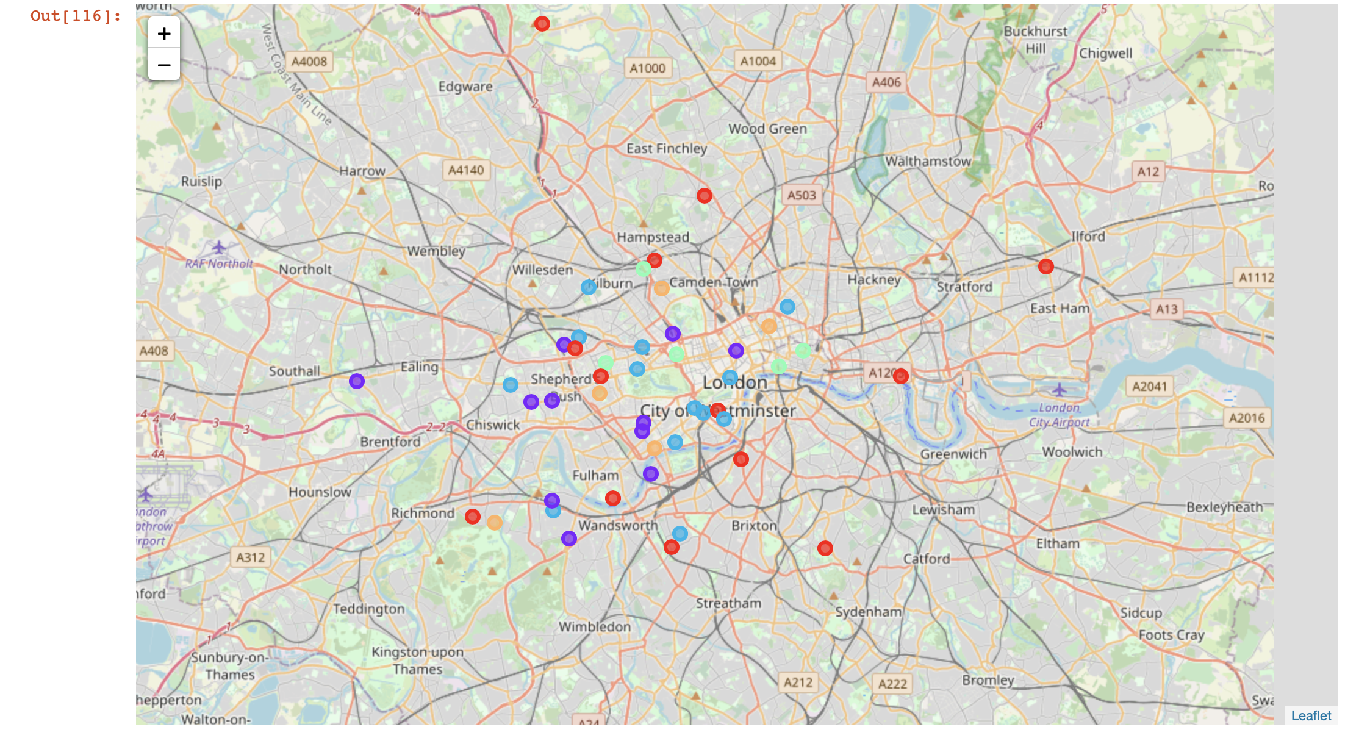

First of all, West London (Kensington, Chelsea, Marylebone areas) and North-West London (Camden Town, Hampstead areas) were expected to pop as a profitable investment due to the wide range of amenities and essential facilities and venues. Yet South-West London (Brixton and Wandsworth, areas) and also Limehouse in East London are also arising as next future venues with a wide range of amenities and facilities. Therefore, South-West London and Limehouse could be a good investment opportunity for those who do not wish to invest in luxurious neighbourhoods like Kensington.

Secondly, by using the clusters the results can be analysed. In a city like London, there will be lots of pubs and restaurants but the clusters show different patterns. As you can see, the 3rd and 4th clusters tell us that those areas are more for people who are more active as it has an harbour, golf course, dance studios and fitness centres. The clusters 0, 1 and 2 can be interesting for investors who love going to pubs cafes and restaurants.

## Conclusion

The UK withdrawal from the European Union had affected the British housing market both for the citizens and non-citizen buyers as the government made it more expensive for landlords and overseas buyers to purchase houses. Especially, real estate in London comes at quite a steep price. Therefore, I tried to find the wisest investment options for people who seek a house in London now that Brexit is finalised. Recommendations of profitable venues according to amenities and essential facilities such as schools, hospitals & supermarkets was also a part of this project.

Data on London properties and the relative price paid data were extracted from the HM Land Registry. For data visualisation, FourSquare API interface is used. Then the collected data from HM Land Registry and Foursquare API is merged and showed the most profitable investments in London.

The Methodology for this project started with Collection of Data then continued with 2. Exploring and Understanding Data, 3. Data Preparation and Preprocessing and 4. Modelling. I used the k-means clustering technique will be used for this project as it is accurate, efficient and highly flexible.

In conclusion, even though, the UK has left the European Union London is still a place that both people would like to invest. Although West London and North-West London were expected to pop as a profitable investment due to the wide range of amenities and essential facilities and venues. Yet South-West London (Brixton and Wandsworth, areas) and also Limehouse in East London are also arising as next future venues with a wide range of amenities and facilities. Therefore, South-West London and Limehouse could be a good investment opportunity for those who do not wish to invest in luxurious neighbourhoods like Kensington. Secondly, by using the clusters the results can be analysed. In a city like London, there will be lots of pubs and restaurants but the clusters show different patterns. As you can see, the 3rd and 4th clusters tell us that those areas are more for people who are more active as it has a harbour, golf course, dance studios and fitness centres. The clusters 0, 1 and 2 can be interesting for investors who love going to pubs cafes and restaurants.